1st December 2020

Dear Families & Friends

As the Christmas season comes upon us can I firstly wish you all the best for December, and hope that you continue to stay safe and well. This year has been so testing for you all and your unwavering support has enabled us to tackle 2020 in the spirit that we have. Please be assured that this support, patience and understanding has been invaluable to us all.

You will be aware that the second period of national lockdown comes to an end on Wednesday 2nd December 2020 and that has prompted discussion as to the possibility of allowing visitors back on site.

Unfortunately due to a positive test amongst the staff group it has been necessary to re-test all staff and patients. The staff member has quickly been isolated and all other safety precautions have been implemented. All tests are being carried out this week and we hope to have the results back as soon as possible.

Sadly, for this reason, it is NOT possible to restart visits at Cotswolds just yet as we need to be certain that this is an isolated case and that the safety of all is ensured.

It saddens me deeply to have to convey this to you all but I hope you can appreciate that trying to keep the virus out from such a vulnerable group and maintaining the safety of staff required to run the unit is imperative.

I am fully aware of how important family contact is and we will be doing our utmost to get these test results back as quickly as possible to shed further light on the situation. I will be meeting with the COVID group on Monday 7th December 2020 to discuss this again and will keep the Cotswolds visiting situation at the forefront of everyone’s mind.

Thank you once again for your patience and understanding, its importance cannot be overstated. I will be writing again early next week with an update.

Yours sincerely
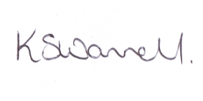

Kathy Swannell
Clinical and Operations Director

