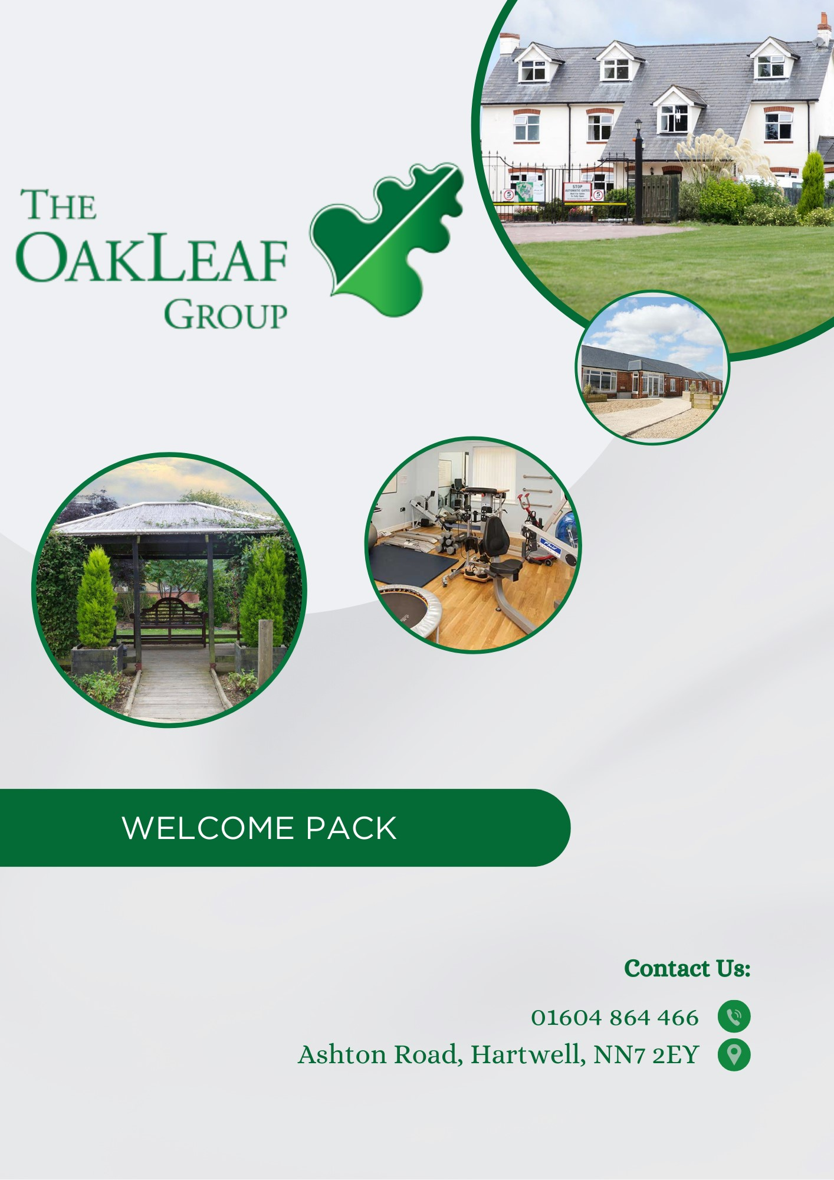

CONTENTS PAGE

CONTENTS | PAGE NUMBER
Welcome to Oakleaf | 1
Admission to Oakleaf | 1
Introducing the Oakleaf Team | 1-2
Your Bedroom | 2
The Structured Care Environment | 3
Food & Drink | 3
Daily Activities & Sessions | 3-4
Review Reports & Meetings | 4
Keeping in Touch with Family & Friends | 4
Mobile Phones | 4
Finances | 4
Smoking & Alcohol | 5
Religious and Cultural Needs | 5
Resident Monthly Meetings | 5
Health & Personal Care | 5
Health & Safety | 5
Concerns & Complaints | 6
Advocacy | 6
Equal Opportunities & Diversity | 7
The Oakleaf Group Lead Staff | 7
Visitors Policy | 8
Surrounding Area Guide | 9

Welcome to Oakleaf! We hope this guide will help to answer any questions and alleviate any understandable apprehensions you may have about Xxxx’s stay at Oakleaf. It is designed to provide you with information around the facilities available at Oakleaf as well as give you a better understanding of what day to day life will be like whilst Xxxx is here with us.
WELCOME TO OAKLEAF
Oakleaf combines a homely environment with an active rehabilitation programme and our goal is to meet Xxxx’s needs at all times to ensure that he not only benefits from rehabilitation, but that his stay is as comfortable and enjoyable as possible.

This guide is also available in large print, a more accessible layout as well in audio format, so please just let a member of the team know if you would like to request one of these versions.
ADMISSION TO OAKLEAF

Xxxx’s admission to Oakleaf will have followed an initial review and the placement would have been approved on either an Acquired Brain Injury Pathway or through our Stroke Care Pathway;

Acquired Brain Injury Placement (minimum 8-12 week placement)
The purpose of this placement is to support Xxxx/you with the affects of a newly acquired brain injury/traumatic brain injury. The focus of admission is for the interdisciplinary team to assess Xxxx’s medical, physical, cognitive, psychological, behavioural needs and communication skills with the ultimate aim of maximising his independence. Throughout the assessment period, the team will develop unique and personalised programmes of rehabilitation.

Stroke Care Pathway (minimum 6-12 week placement)
This placement is designed to support both Xxxx/you with the affects following a recent stroke. The interdisciplinary team will assess Xxxx’s needs around his medical, physical, cognitive, psychological, behavioural and communication skills to build an intensive rehabilitation programme with the ultimate goal of maximising his functional skills and independence as much as possible.

What to expect on your admission day and afterwards;
Upon arrival to Oakleaf Xxxx will be greeted by the care team, who will take him to his own private room and ensure he has everything he needs to help settle in. You are more than welcome to be with Xxxx on his admission day.
The first few days at Oakleaf will completely revolve around ensuring Xxxx is orientated to his bedroom/the unit/the grounds and to ensure he feels as settled as possible.
After the first few days, Xxxx will be introduced to the different therapy teams who will start to conduct assessments. They will discuss current ability as well as future goals with the aim of implementing his own timetable of sessions.
INTRODUCING THE OAKLEAF TEAM

The Oakleaf Group team is made up of a large interdisciplinary team, all specialising in different areas of your care. Northampton has a Registered Medical Officer, Dr Bryan Timmins who is a Consultant Neuropsychiatrist and Dr William Hunt who is our dedicated GP from Bugbrooke Medical Practice who attends Oakleaf every Monday.

Oakleaf also benefits from the expertise of a qualified Consultant Clinical Neuropsychologist, Dr Caroline Knight, a Clinical Psychologist, Dr Fiona Werrell, together with Qualified Physiotherapist, Nurses (RGN, RMN and RNLD), Occupational Therapists, Speech and Language Therapists, Social Worker, Therapy Assistants, Horticultural Staff, Physical Health Nurse, Chefs and a Dietitian. The overall management of the Oakleaf Group is led by Clinical Director and RMN Kathy Swannell.

Xxxx will be allocated a Named Nurse and a named Associate Nurse who are specifically there to help meet his needs. Please note that if for any reason Xxxx finds that he builds a better rapport/relationship with a different member of the team, you are welcome to request for a change in allocated personnel. It is vitally important to us that Xxxx feels at ease and comfortable when discussing his care needs with this person so please do not worry about asking for this.
Page 1

All staff at Oakleaf wear a uniform in the form of a polo shirt. Each team member will have a colour depending upon their particular role:
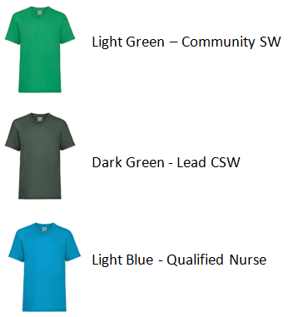
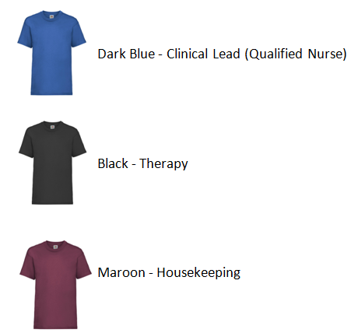
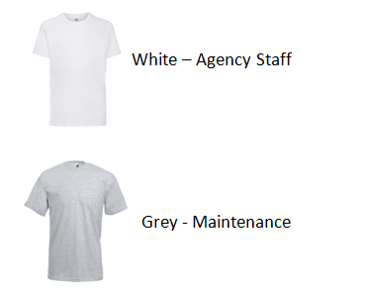

Oakleaf staff who do not wear a uniform will wear a badge or lanyard, which clearly states their name and their job role. Badges are also worn by those in uniform stating their names and job roles.

If you find it difficult to make out the names on the staffs name badges, please let a member of the team know as we also have badges with larger font or coloured backgrounds available for our staff to wear.

YOUR BEDROOM

Xxxx will have his own bedroom with en-suite facilities. We encourage you to bring in any personal items that will help Xxxx feel more settled during his stay with us; for example, pictures, posters, etc. Please not that any illegal, dangerous or banned items will not be allowed, such as alcohol or knifes etc.

The team will have completed an inventory checklist upon admission, but please do keep the team informed of any new items so they can ensure this is kept up to date.

Xxxx’s room will have a TV point and you will be able to bring or purchase your own TV for him. You may also wish to bring other electrical equipment such as a radio, DVD player or a games console. For safety reasons all electrical equipment will be PAT tested by Oakleaf; (this will in no way damage or affect its working). Xxxx is also able to have his own computer/tablet and Oakleaf will provide Wi-Fi internet codes.

For safety reasons, residents are not permitted to have any naked flames (e.g. lit candles) in their bedrooms.

There is daily housekeeping who will help to ensure the cleanliness of the room as well as laundry assistants who will complete all laundry tasks. We do however appreciate that it may be important to Xxxx to be able to do his own laundry, so please just speak to a member of the team and we can support with that too. To ensure clothing is easily identifiable during laundry we do please ask if all clothing can be labelled. Xxxx will also be regularly supplied with fresh bed linen and towels.

Some residents do wish to hold a key to their bedroom to ensure they are able to lock it when they are not using it, so please ask staff if this is something Xxxx would like and they will assess the safety issues around his room.

Where possible, we would encourage social interaction with other residents to take place in the communal areas on the units rather than in the bedroom.

Page 2
THE STRUCTURED CARE ENVIRONMENT
Our top priority is ensuring that the care environment at Oakleaf is welcoming, comfortable, clean, tidy and as safe as possible to ensure all our residents feel at ease during their stay here. We inspect the environment regularly and thoroughly for any breakages, repairs or general cleaning issues to ensure it stays that way. Keeping our residents safe is always at the forefront at Oakleaf which is why we have a gated entrance and keypad entry to all units.

Being set in the country, there is some beautiful scenery that can be enjoyed from the communal outdoor spaces available, which Xxxx will have access to during his time here. When enjoying the grounds, we just ask that you ensure a member of the team is aware of where he is, in the very unlikely event of an emergency, such as a fire.
On the main unit at Oakleaf we have a multi gym and exercise room/games room to use either during session times or in free time. We also have a large resource of games, activities and crafts which also includes outdoor activities.

NB: As Oakleaf is a safe facility, a risk assessment may need to be completed with before being able to access certain areas.

Oakleaf also provides communal lounges on all our units which are spaces where Xxxx is able to listen to the radio or watch TV/DVD’s in his free time. These rooms are also used to host some of the communal sessions, so there may be times where the use of the lounge is more limited.
FOOD & DRINK

Food and drink is an important aspect of feeling comfortable during Xxxx’s stay at Oakleaf, which is why we strive to provide an excellent selection of meals, focusing on choice and healthy options.

XXXX will be provided with a menu where he is able to choose what meals he would like and we have full time chefs on site to ensure all meals are freshly prepared daily.

We are proud to be able to cater for allergies, religious/cultural diets, vegan/vegetarian, celiac as well as any specially modified diets to ensure every resident’s nutritional needs are met during their time at Oakleaf. If you would like to discuss any needs further though, please do always ask a member of the team.

Whilst meal times are not structured, the below information will be a guide for when each meal starts to be served;
Breakfast; from 8.30am daily
Lunch; from 12.30pm daily
Evening Meal; from 5.30pm daily

We have communal dining room facilities and for comfort and we encourage that all meals are eaten within these facilities.

If Xxxx has his own personal food/drink, this will be kept in a safe place by our team, but will of course be available on request. If you or any other visitors bring food in for Xxxx, please just ensure that it is labelled and only consumed by Xxxx to avoid any risks/allergies with other residents.

Hot/cold drinks are available during the day, and a member of the team will be on hand to assist with making them if required.

Fresh fruit is also available throughout the day.
DAILY ACTIVITIES & SESSIONS

Daily activities and sessions at Oakleaf play a huge part in rehabilitation, and it’s important to us that Xxxx is involved in the planning of these. That’s why after initial assessments the team will sit down with Xxxx to create his own person centred timetable, which he will be shown where to access or are able to have a printed copy to keep.

Therapy Assistants are available to help with the timetable and within sessions to ensure they run smoothly. They are also there if Xxxx would like to discuss any issues or if he has any requests with the timetable.
Page 3
The named nurse will discuss any care plans and risk assessments with Xxxx directly.

Oakleaf has its own vehicles, some of which are specifically for wheel chair users and we aim to facilitate day and evening activities away from the units to ensure residents get as much opportunity to chose and enjoy community trips as possible.

Each unit at Oakleaf also organises a monthly takeaway; residents decide upon what takeaway they will have as a group. As well as unit takeaways, Oakleaf also organises regular social gatherings, including BBQ’s and tea parties across all units for all residents to enjoy.
REVIEW REPORTS & MEETINGS

During Xxxx’s stay at Oakleaf there will be regular reviews and meetings held regarding his rehabilitation and funding, which Xxxx and family/friends will be invited to attend. These reviews are an opportunity to discuss your progress as well as future goals. If Xxxx is unable or does not wish to attend the review in person but would like to know about the content of the review reports/meetings or would like to have a copy of the reports, please speak to the Nurse in Charge or any of the care team.
KEEPING IN TOUCH WITH FAMILY & FRIENDS

We understand how important it is for Xxxx to keep in contact with his family and friends, so our team will be there to help him to keep in touch with them. We have a flexible policy for visitors; however due to Xxxx being in sessions through the weekdays, we do ask if visitors can come after 4.30pm on weekdays, but weekends are completely flexible. However, if you would like to visit outside of these times, then please just let us know in advance so we can ensure no sessions are planned during the time you will visit.

Please note that for safety reasons we are unable to have under 18’s on the units, however there are designated rooms and areas within the grounds where visits can take place with children.

Please ensure all visitors let our reception team know when they will be coming to visit you so we can ensure you are aware and are happy for these visits to take place.

Oakleaf staff can also assist with letter and card writing and can also supply all the materials for doing this; including posting them for.

A telephone facility is provided on all units for residents to keep in touch with their family and friends. Staff will let Xxxx know about any incoming calls he receives and if he is unavailable at that time (due to being in sessions or out in the community), staff will take a message which will be given to him as soon as possible.
MOBILE PHONES

Please just let a member of the team know if Xxxx requires assistance with using his mobile phone, they will be on hand to offer any support he may need with it.
To protect our other residents and staff’s privacy and confidentiality, every member of staff and every resident at Oakleaf are not permitted to use the camera/recording function on their phones. We also ask that all face time/video calls take place in your bedroom, not in the communal areas.

YOUR FINANCES

We understand that dealing with finances during a stay at Oakleaf might be stressful and cause unwelcomed worry, so our team will be available to support Xxxx with any questions or concerns he may have. This includes offering advice and practical support to access benefits he could be entitled to.
If Xxxx is unable to manage his finances, our team will be able to support a key family member and provide information about how they can become involved to help manage his finances.

If Xxxx has any money on site, we provide a safe where the money can be safely stored, which is checked regularly by authorised staff members, if required.
Page 4

Whilst smoking is prohibited in all indoor spaces, we do have designated covered outdoor areas available to use. To maintain safe smoking practices, a risk assessment will be carried out shortly after admission to Oakleaf; this will also include an assessment around keeping any smoking materials (e.g. lighters, etc) in a bedroom or on his person. We can also provide help and support to stop smoking at anytime, please just ask the Nurse in Charge or care staff.
SMOKING & ALCOHOL

Oakleaf does not provide alcohol, however in some cases the unit doctor may give permission for you to consume alcohol whilst here. This will be discussed with Xxxx and a care plan and contract will be devised and drawn up. For safety reasons, all alcohol must be given to the Nurse in Charge/care staff who will store it away in the clinic fridge and this will be given at the appropriate times.
RELIGIOUS & CULTURAL NEEDS

At Oakleaf we acknowledge the importance of your individual spiritual, cultural, and religious needs and beliefs. We will ensure all staff have an understanding of these needs and beliefs and ensure the appropriate resources, services, and places of worship are accessed when and where possible.

Where required Oakleaf will access religious and cultural materials for you, we can also provide any religious or cultural dietary requirements you may require. You are able to attend church or other places of worship; please ask a member of the care team to show you the list of available services.
RESIDENT MONTHLY MEETINGS

Once a month every resident at Oakleaf is encouraged to attend a ‘Resident Monthly Meeting’. The purpose of this meeting is to give residents the opportunity to express their likes, dislikes and requests with care staff. The aim of these meetings is to ensure that all residents feel that they have a voice and also have a say in what goes on, what they would like to change, improve, introduce or simply just comment about. The team that facilitate these meetings will then ensure that all comments/requests are forwarded to senior management for discussion with potential actions to help maintain and improve the quality of the service/environment provided by Oakleaf.

HEALTH & PERSONAL CARE

The care team are there to help monitor Xxxx’s health and wellbeing whilst here at Oakleaf. Xxxx will have access to GP services, dentistry, a dietician, chiropody and also a consultant, who will monitor overall care/health. We also employ registered general nurses and have access to other health professions such as asthma/diabetes nurses, a practice nurse and community and pressure care nurses. We are also able to access other qualified professionals to help with any specific health needs or concerns that you may have.

Our care team and doctor are available to speak to regarding any queries/concerns with any prescribed medication. We also have a medicine resource folder which offers further explanation on any medication prescribed whilst at Oakleaf which is available to see at any point. Please just speak to a member of the team.
You can request any specific health promotion information and also request a visit from the GP, unit doctor or any other service/professionals mentioned; please just ask the Nurse in Charge or any member of the care team who will be able to arrange this.

If you have any concerns about your health, please tell a member of staff straight away.
HEALTH & SAFETY
If you would like to know more information regarding health and safety issues such as fire evacuation guidelines/policies etc. please speak to a member of the team who will be able to provide you with them.

Page 5

CONCERNS & COMPLAINTS
Whilst we hope Xxxx will not have any problems during his stay at Oakleaf; if he does then we will ensure that any concerns are treated seriously and dealt with in the appropriate manner.

We operate a comprehensive complaints procedure and a complaint can be made to any member of the Oakleaf team, who will ensure the correct procedure is followed (please see the accompanying leaflet).

You are able to book a time with any of the senior managers and they will be happy to meet with you and help in any way they can.

Xxxx’s views and opinions are valuable to us all at Oakleaf so if he has any suggestions or ideas, please speak to the Nurse in Charge or any member of the care team. There are also feedback boxes on every unit where provide anonymous feedback can be provided.

Oakleaf are inspected by the Care Quality Commission and the subsequent reports are available online to download or reports can be supplied to you in paper form on request; please see any member of the care team.

Please see below additional information on who you can speak to if you have any concerns;
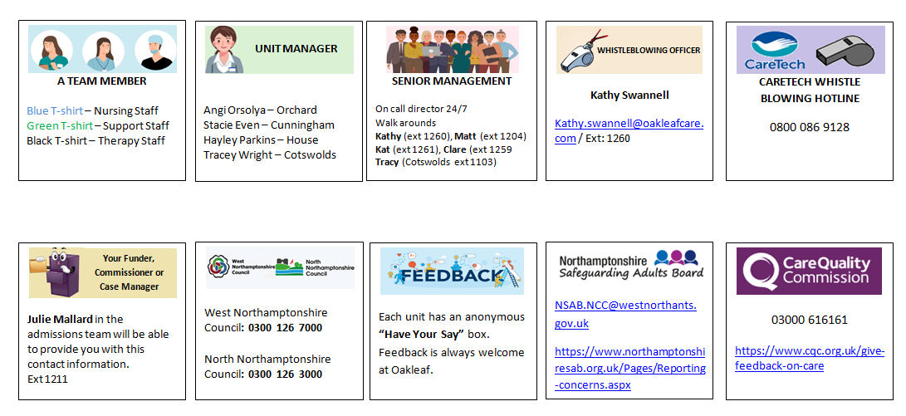

ADVOCACY

Advocacy means getting support from another person to help you express views and wishes, and help you stand up for your rights. The role of an advocate depends on your situation and the support you want.

An advocate can:
- Listen to views and concerns
- Provide information to help make informed decisions
- Help contact relevant people, or contact them on your behalf
- Help explore options and rights (without pressure)
- Accompany and support in meetings or appointments
- Support if you are finding it difficult to explain wishes and feelings.
- If Xxxx needs help to access an advocate during his stay, a member of staff who help to make contact with an advocate.

Page 6

EQUAL OPPORTUNITIES & DIVERSITY
Oakleaf is fully committed to a policy of promoting Equality and Diversity throughout the organisation; this will be accomplished through the provision of training and development of managers and employees to ensure a supportive working and home environment for all employees, service users, tenants, young persons and customers. The Company will endeavour to ensure that everyone is treated with dignity and respect; it is the policy of the Company that no person acting on our behalf shall discriminate in any situation against another individual or group, directly or indirectly. All employees, whether part-time, full time or temporary will be treated fairly and with respect. Selection for employment, promotion, training or any other benefit will be on the basis of their individual aptitude and ability to carry out duties expected of that post. We are a Disability Confident employer and are committed to recruiting, retaining and supporting disabled employees. We aim to remove barriers, resolve issues relating to disability and consider individual needs. This includes taking positive steps towards promoting equality of opportunity, inclusion for all and promoting positive attitudes towards disabled people.

THE OAKLEAF GROUP LEAD STAFF

Clinical and Operations Director/Registered Manager - Kathy Swannell
Deputy Operations Director - Matt Poulton
Manager of Clinical Quality and Excellence - Kathryn Mackmin
Nurse Manger – Clare Bentley
Operations Manager – Brad Patton
Medical Director - Dr Bryan Timmins
Dedicated GP – Dr William Hunt
Head of Psychology and Therapeutic Programme- Dr Caroline Knight
Clinical Psychologist – Dr Fiona Werrell
Unit Manager (The House and Lodge) – Hayley Parkins
Unit Manager (Cunningham House) – Stacie Even
Unit Manager (Orchard House) – Angi Orsolya
Unit Manager (The Cotswolds) – Tracey Wright
Unit Manager (Community Houses) – Kate Thomson
Lead Assessor – Dan Gordon
Social Worker – Sue Clayson
Social Work Assistant – Seth Partridge-Underwood
Recruitment and Wages Manager - Kathryn Wright
Referrals & Admissions Co-ordinator – Julie Mallard

We hope this guide has been useful and has helped to give you any information you may, however, please do always speak to a member of the Oakleaf team if you have any questions at all.

Page 7
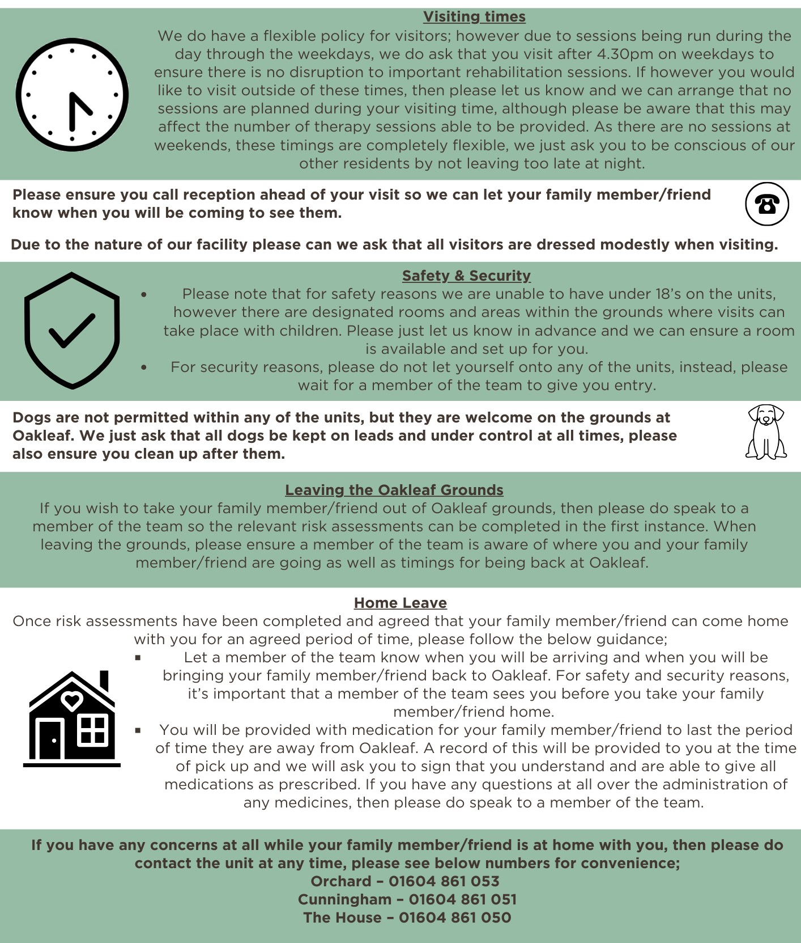
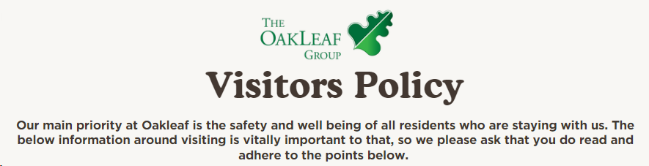
Page 8
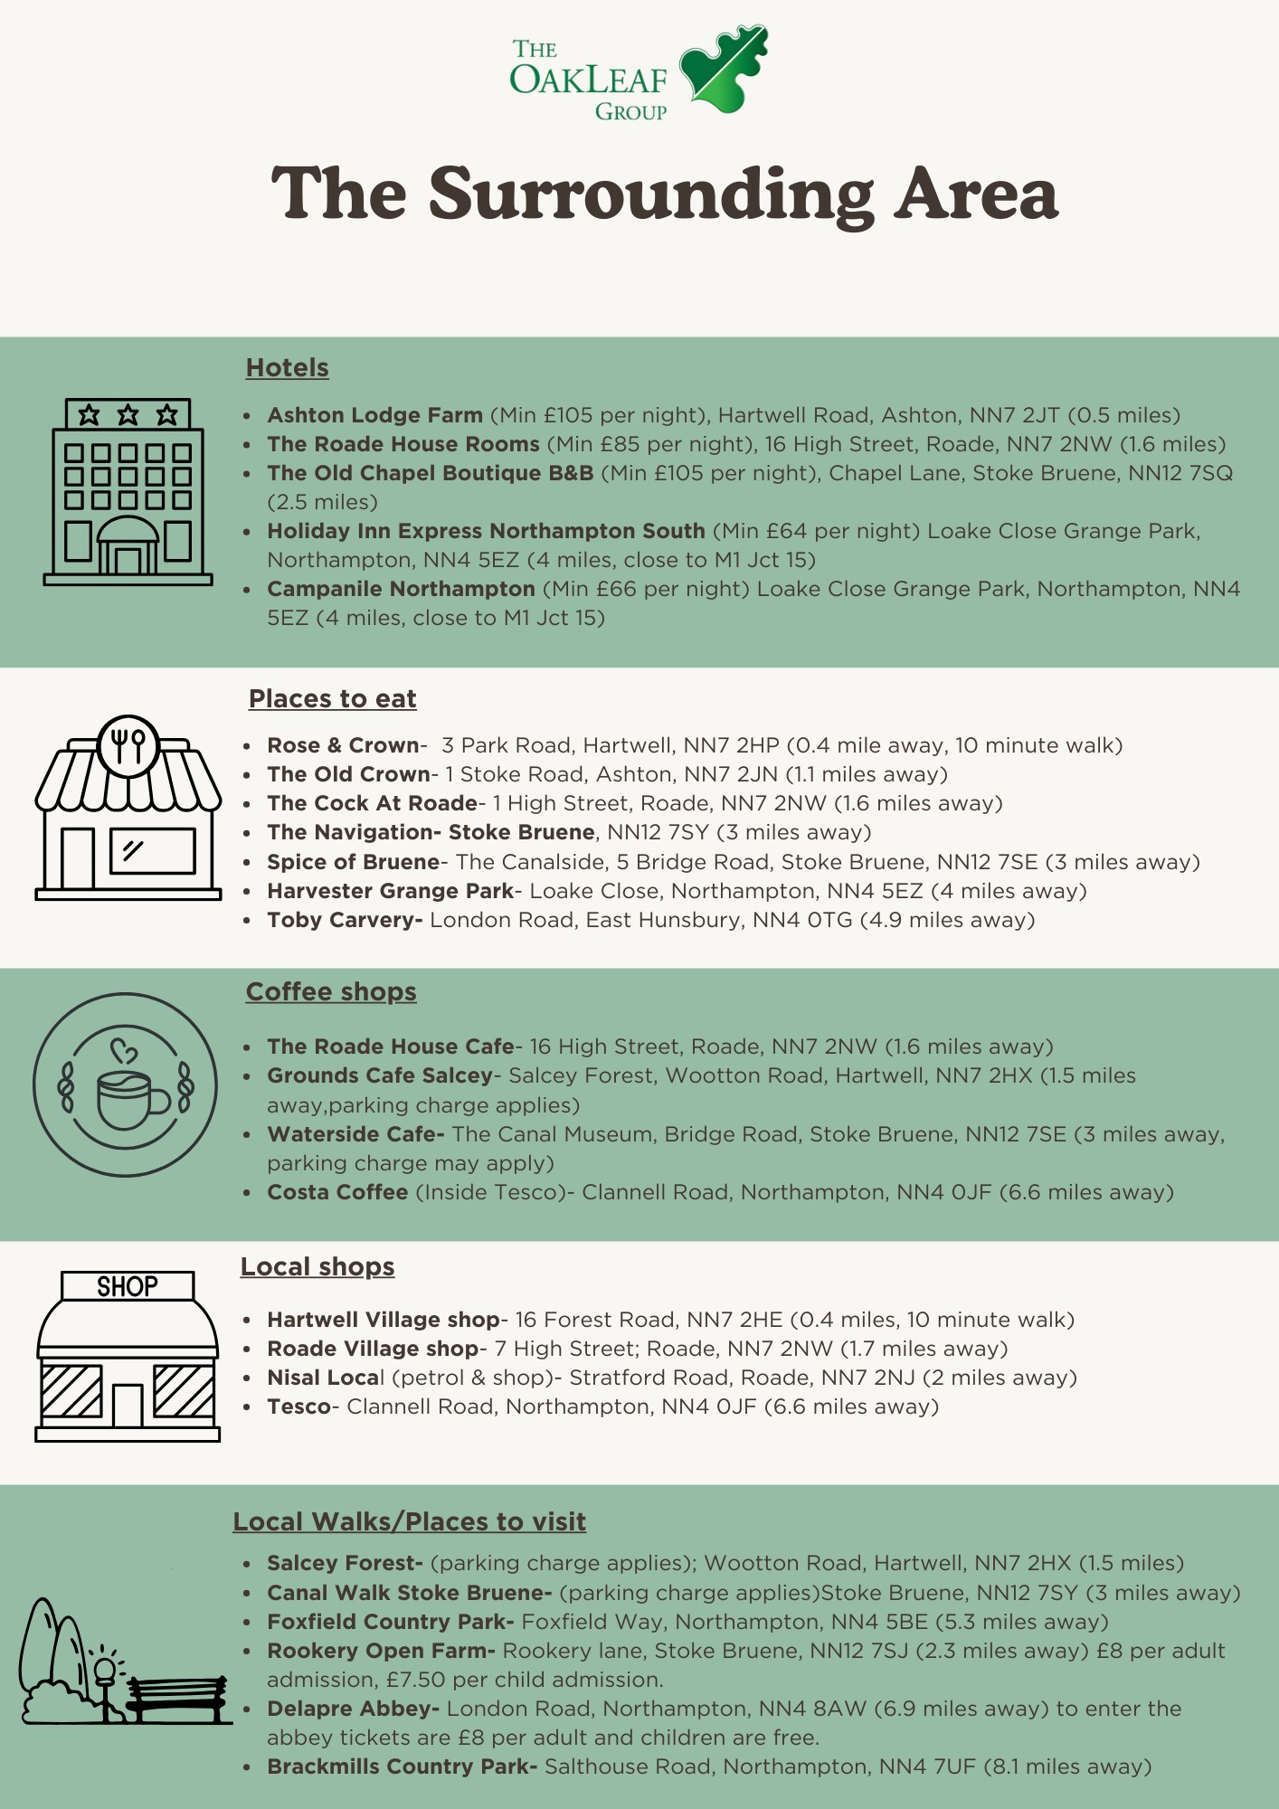
Page 9
LOCAL SHOPS
CAFES

